**ASSIGNMENT-3**

U19CS012

**Design and verify their functionality of below circuits with the help of Multisim.**

**1.** Design and implement Half Adder and Half Subtractor (Single Circuit) using Mode Control ‘M’.

*a.) Implement the circuit in Multisim online*

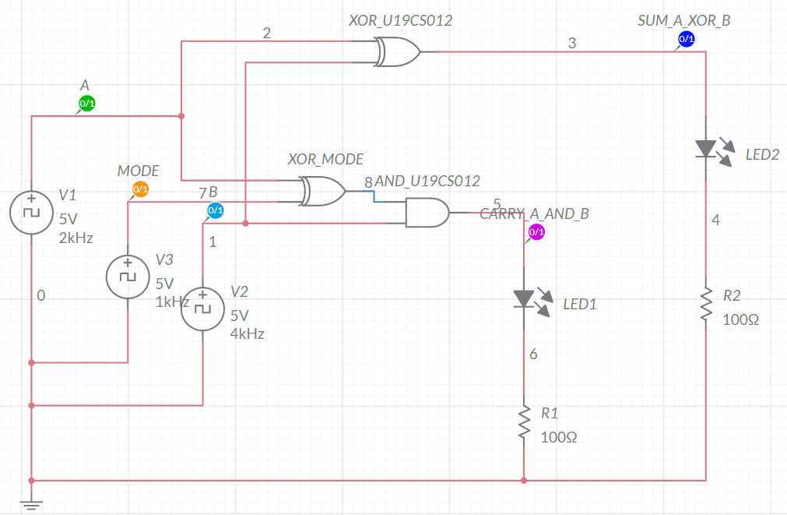

*b.) Timing Graph*

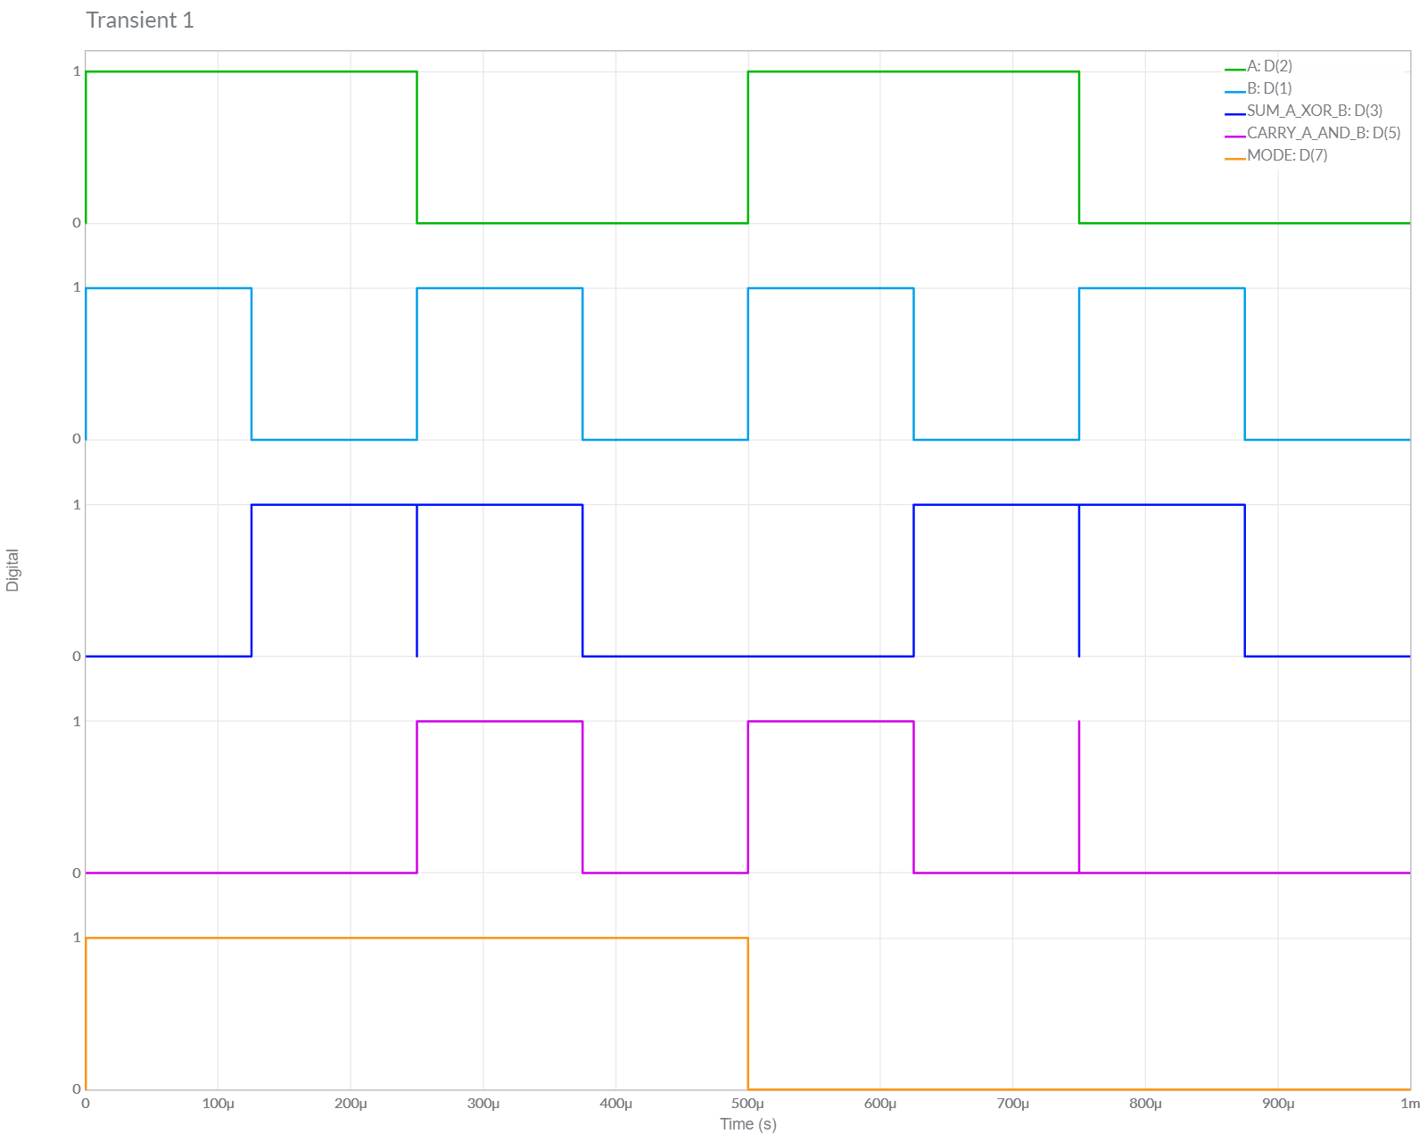

c.) Truth Table:

When Mode = 1, Circuit Behaves as Half Subtractor Circuit

Borrow Out, Bout= A’ . B

Difference, D = A ⊕ B

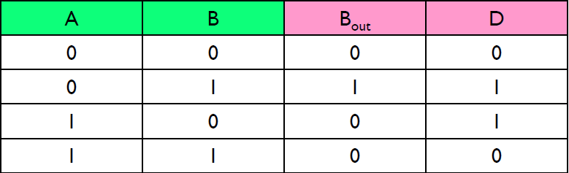

When Mode = 0, Circuit Behaves as Half Adder Circuit

Sum, S = A ⊕ B

Carry, C = A . B

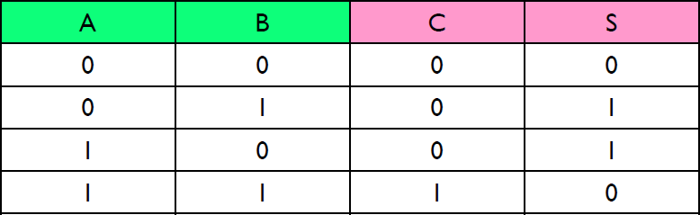

*The Same Truth Table is Followed for Next 2 Questions as well*.

*Conclusion:*

We can observe from Above Table, Both the *Theoretical* and *Multisim* Values of Given Circuit are **Equal**.

Hence, Experiment is Performed Successfully (without any Error).

**2.** Design and implement the circuit in question ‘1’ by using least number of NAND gates only.

Minimum NAND Gates Required = 9

*a.) Implement the circuit in Multisim online*

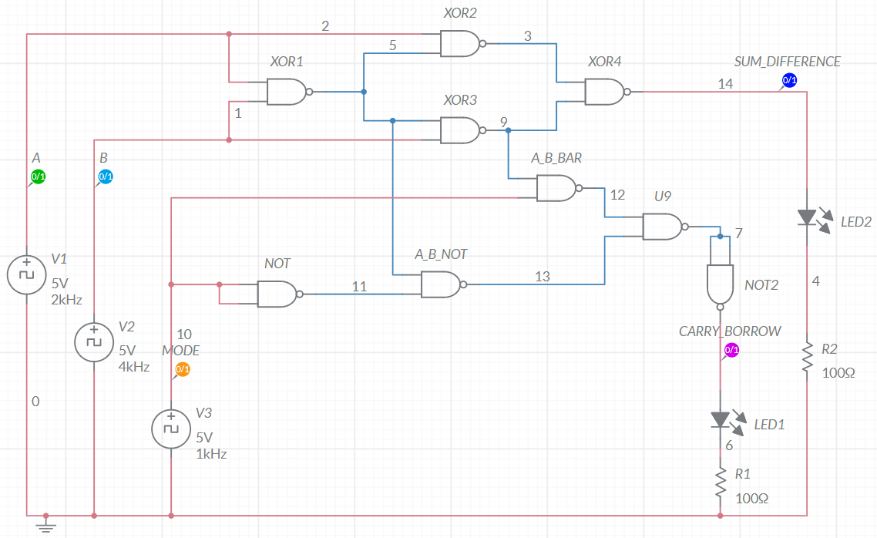

*b.) Timing Graph*

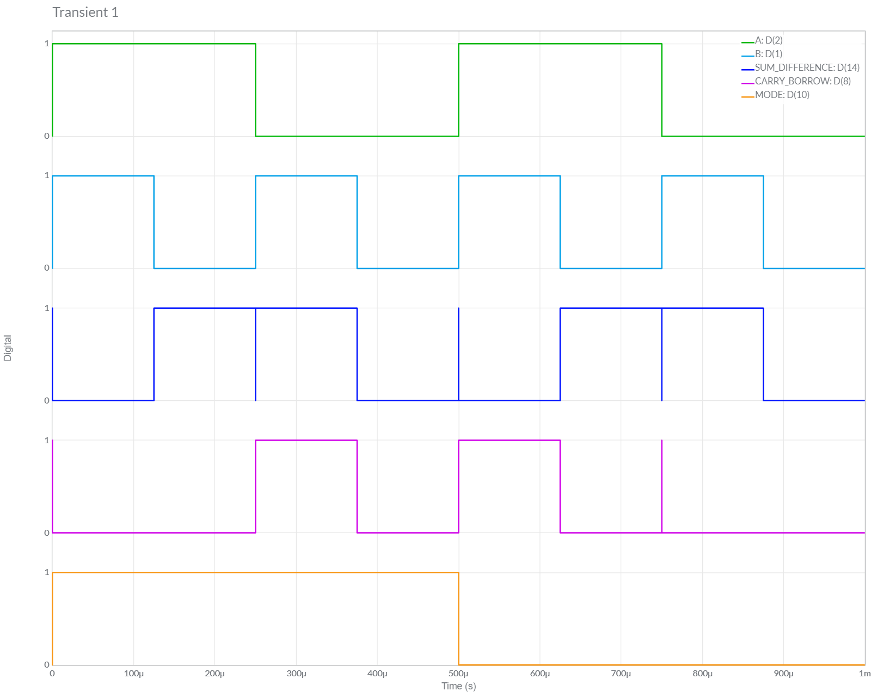

*Conclusion:*

We can observe from Above Table, Both the *Theoretical* and *Multisim* Values of Given Circuit are **Equal**.

Hence, Experiment is Performed Successfully (without any Error).

**3.** Design and implement the circuit in question ‘1’ by using least number of NOR gates only.

Minimum NOR Gates Required = 10

*a.) Implement the circuit in Multisim online*

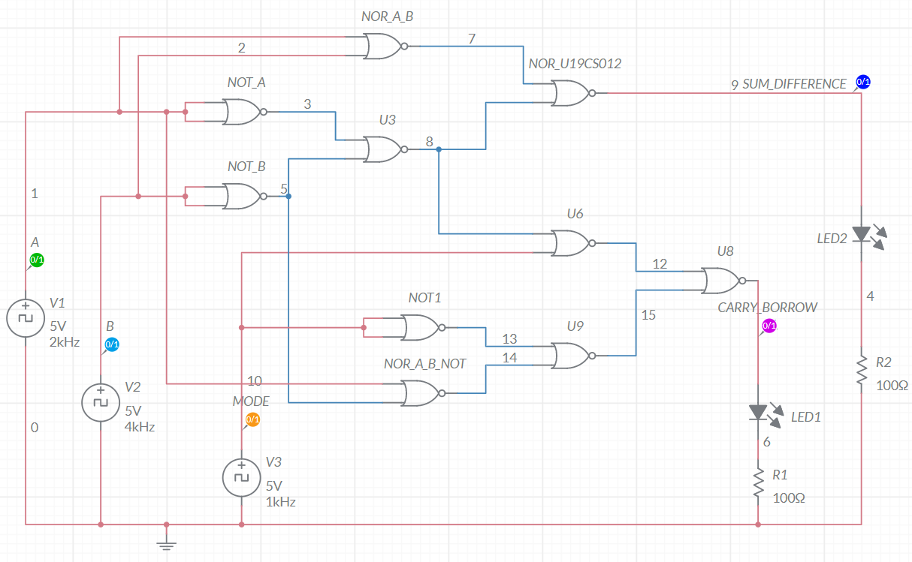

*b.) Timing Graph*

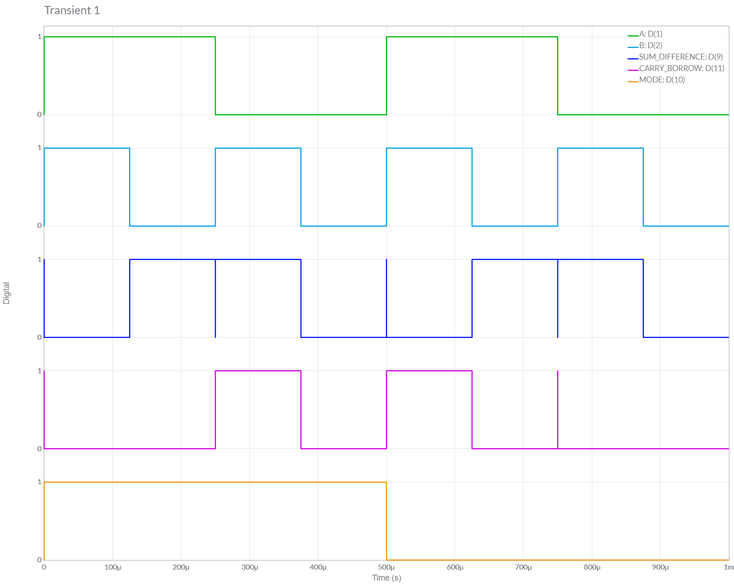

*Conclusion:*

We can observe from Above Table, Both the *Theoretical* and *Multisim* Values of Given Circuit are **Equal**.

Hence, Experiment is Performed Successfully (without any Error).